Template for Evidence(s)
UI GreenMetric Questionnaire

University : ...
Country : ...
Web Address : …

[2] Energy and Climate Change (EC)
SAMPLE
[2.5] Renewable Energy Sources in Campus

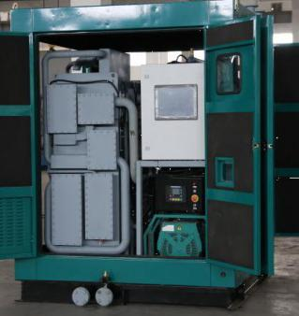 | 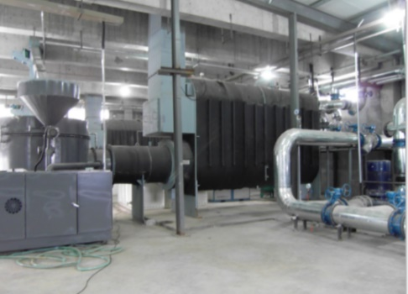
Example of Biodiesel Combined Cooling Heating and Power Integration Unit (Shandong Normal University - Lishan College, China) | Example of Biomass Pellet Vacuum Boilers Provide Heating for the Building in winter  (Shandong Normal University - Lishan College, China)
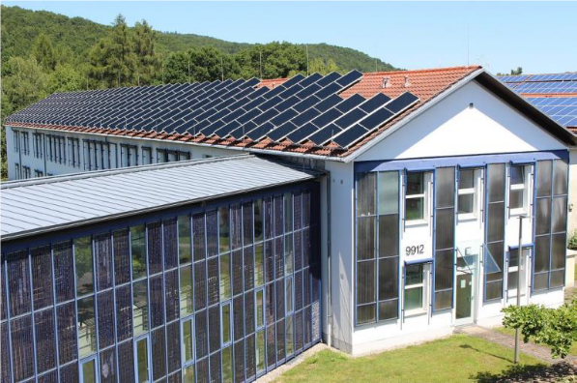 | 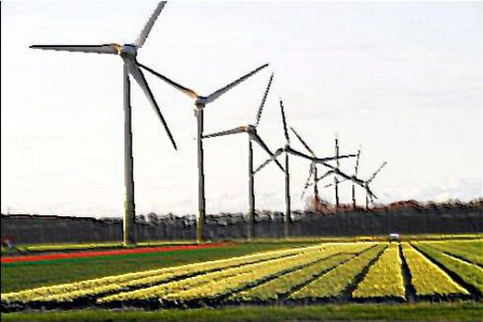
Example of Roof and Façade Mounted Solar Panels (Umwelt-Campus Birkenfeld, Germany) | Example of Windmill Parks (Wageningen University & Research, Netherlands)

Description:
(Please describe the renewable energy sources on your campus. The following is an example of the description. You can describe more related items if needed.)

The evidence provided may also include maps showing the location, area size, or distribution of facilities relevant to the indicators. If you have other sources of renewable energy, you may include and explain them in the evidence.

- The combined cooling, heating and power (CCHP) unit in Lishan College using biodiesel as fuel, is located in the square of the school's restaurant. The rated power of the generator is 30kW, whose waste heat can be used for heating bathing hot water.
- On roofs of administration building, library, laboratory building, school factories and other teaching buildings and dormitories, solar PV power station of total 1.6MW is installed.
1# energy station has 2 biomass vacuum boilers, and each boiler is 7MW, providing heating for most of the school buildings in winter, using the crop straws as fuel. Biomass vacuum boiler can meet Chinese ultra - low emission standards due to the installation of bag type dust collectors and denitration equipment. Biomass pellet fuel and geothermal energy only provide heating in winter.

Additional evidence link (i.e., for videos, more images, or other files that are not included in this file):

